Фестиваль поэзии и музыки для учащихся 9-11 классов ”In the World of Love, Poetry and Music”
Цели проведения фестиваля:
1.Учебный аспект: практика коммуникативных навыков учащихся в говорении (диалогической и монологической речи), выразительном чтении стихов английских поэтов и исполнении песен на английском языке.
2.Развивающий аспект: развитие памяти и способности учащихся осваивать и представлять поэтический язык.
3.Воспитательный аспект: воспитание коммуникабельности, толерантности, уважения к иноязычной культуре; эстетическое воспитание.
4. Социокультурный аспект: знакомство с культурным наследием страны изучаемого языка.
Задачи:
- Учить учащихся фонетически и интонационно правильно читать стихи и петь песни на английском языке
- Учить учащихся артистично читать диалоги из произведений английских писателей
- Учить учащихся умению вести себя на сцене и взаимодействовать во время репетиций
Script
Festival “ In The World of Love, Poetry and Music”
1. Dear friends! Welcome to our festival of love, poetry and music.
2. We are glad to see you here. Spring is coming and our souls are filling with happiness and love. We are waiting for something unusual.
1. We think that poetry and music will help you to preserve these feelings.
2. So we begin. Listen to the poem “ Twilight” by George Gorden Byron –P is reciting the poem and P is presenting you her own translation of the poem.
2. P is playing the guitar and singing the song
***
- Really happiness is when you are loved and when you love somebody as faithfully as you can.

- But people are born to dream and to create things. Let’s listen to Shakespeare’s “Sonnet 66 ” recited by P
***
- Now let’s listen to the song “Lonely Day”
P***
- Love is a popular topic when a discussion about love begins. The poem by G. Hood
“ To a False Friend” - P and P
***
- Love to dance? Then see modern dance “ With the Times”
***
2. One of the main questions is “ What is love? “ Listen to the poem about love by Robert Burns “Oh, My Love Is Like a Red, Red Rose” P
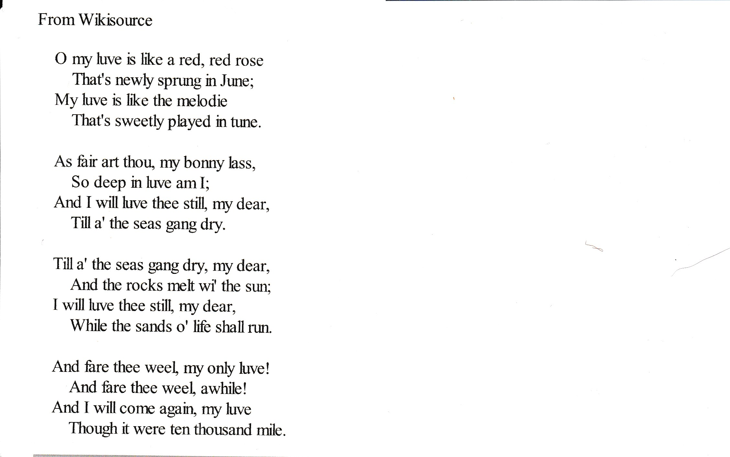

***
2. Let’s listen to the magic violin melody. It sings about love. P , you are welcome.
***
1.Great poets loved themselves and wrote poems to their sweethearts. Now listen to the poem “ She Walks in Beauty” by Georg Gordon Byron – P is reciting

***
- P is singing “Love Story…”….
***
1. And now we are ready to meet our younger friends.

2.Open your hearts to the poem by Rudyard Kipling “If.” He wrote it as a will to his son.
***
2.Our younger friends have one more surprise to us – the scene from the tragedy by William Shakespeare “ Romeo and Juliet “. Juliet – Р, Romeo – Р.

***
1.I’m sure you admire the verses and songs about love. There are some verses and music for you about love. Enjoy yourself. The song……… Р

***
2.And again W. Shakespeare “ To Be or not to Be.” The students of the 10 Form are acting.

- The famous song “ Why Can’t We Be Friends” – 10 Form students
***
- Let’s create a happy and cheerful atmosphere.
- And now a perky dance “Boogie-Vugi”
***
- We wish you love,
- true love
1-2.( together) that fills your heart with very special feeling.

